

PROJECT FOLLOW UP

The Lost Diamond

2026/2027

EMBEDDED AND UBIQUITOUS SYSTEMS

Abril Tufet
Ainhoa Ferradás
Edna Solans
Marc Companys

1. Game definition
1. Name of the game
The Lost Diamond, a physical, Arduino-supported board game inspired by Afrikan Tähti / The Star of Africa.

2. Indicate in summary what the game will consist of.
Four players explore a tropical archipelago using a physical board with five islands and 16 marked positions. Each player starts at a separate starting space (Up Left or Down Right). A central ESP32 station provides a push-button dice (random result 1–3), a display for actions and special spaces, and a buzzer. NFC technology links the physical spaces to the digital game state. The first player to find the diamond and reach the starting position wins.
The board has two main islands, one medium island and two small islands. The 16 red circles in the supplied map are the intended game-space locations.
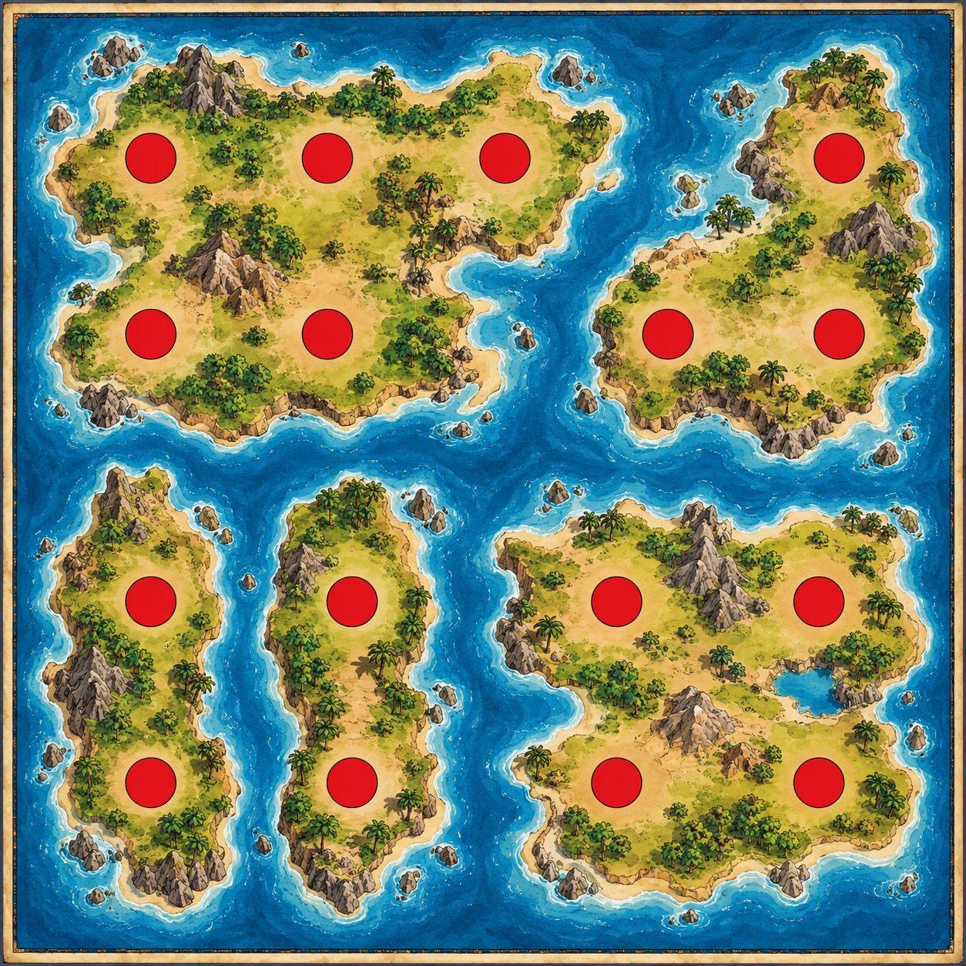
Figure 1. Proposed board layout: five islands and 16 red game-space markers.

3. Evolution rules
- Setup: use two starting positions (Up Left or Down Right), with one pawn per player. The 14 rest physical positions receive unique identifiers and one type of action.
- Turn: the active player presses the central button. A random integer from 1 to 3 is displayed; the player moves and the destination is registered through the chosen NFC interaction.
- Occupancy: a player may neither cross nor stop on another player’s occupied position. How to resolve a blocked throw must be agreed during map-graph design.
- Special spaces: on landing, immediately resolve the action described in the table below. A gold coin space gives an additional throw; a shipwreck space makes that player miss their next turn.
- Diamond reveal: the first time the diamond space is discovered, show “THE LOST DIAMOND!!” and play a short buzzer melody. From that point, emit a ticking sound and show a small diamond icon in the display corner during later throws.
- After the diamond has appeared, pirate spaces become ordinary blank spaces and no longer send players back to their respective starting positions.
- Victory: once the diamond has appeared, the first player to subsequently land on either horseshoe space and go back to starting position wins. The screen announces “HORSESHOE!!”.

Space distribution
Space / event | Count | Effect
Starting point (Up Left or Down Right) | 2 | Initial pawn locations.
Diamond | 1 | Reveals the diamond; triggers melody, ticking and screen indicator.
Pirates | 2 | Return to own start until diamond reveal; blank thereafter.
Horseshoe | 2 | Winning destination only after the diamond has appeared.
Gold coin | 2 | Immediate additional dice throw.
Blank | 5 | No special effect; the turn ends.
Shipwreck | 2 | Skip the next scheduled turn.
Inter-island movement (to validate): Main to Medium = 2, Main to Small = 3 and Small to Small = 1.

2. Development aspects
1. How is it planned to distribute the development tasks among the working group?
Each member owns one subsystem, reviews another member’s work, and participates in final integration.
Owner | Primary work package | Expected outputs
Member 1 — Game rules & logic | Turn state, die outcome (1–3), board graph, legal moves, occupancy and special-square rules. | Game engine, defined APIs, unit tests for gameplay.
Member 2 — Board & NFC | Physical board coordinates, numbering of 16 NFC positions, tag identification and reader communication. | Annotated map, NFC lookup table, working read-and-report prototype.
Member 3 — Central station | Microcontroller wiring/firmware for push button, display and buzzer; electrical reliability. | Wiring diagram, button/display/buzzer drivers, demonstrated central station.
Member 4 — Interface, integration & QA | On-screen game messages, diamond indicator, orchestration of modules, test plan and documentation. | UI states, integrated build, test log and demo/hand-in package.

2. What are the intermediate milestones for the development of the project?
The milestones below form a four-week plan relative to project kickoff. Dates may be adjusted to the actual coursework deadline.
Milestone | Target | Acceptance criterion
M1 — Specification freeze | End of Week 1 | Final 16-space map and adjacency/crossing rules agreed; parts and interfaces defined.
M2 — Working subsystem demos | End of Week 2 | 1–3 button rolls on display, buzzer output and at least one NFC tag reliably read.
M3 — Fully playable alpha | End of Week 3 | Both players can complete turns; all special events and the win condition work.
M4 — Validated final demo | End of Week 4 | All 16 markers tested; regression tests passed; demonstration and hand-in ready.

3. Indicate the expected schedule for the development of the project, distributed by tasks and those responsible for the tasks.
Expected schedule by task and accountable person. Tasks in the same week may be worked on in parallel once their interfaces are agreed.
Week | Development task | Deliverable / check
1 | Confirm game flow, conditions and route graph | Rule sheet and move-validation tests
1 | Number/map 16 circles and select NFC read method | Board–ID mapping and feasibility check
1 | Confirm components, pins and wiring | Station schematic and bench test
1 | Define display states, test cases and interfaces | UI mock-up and integration contract
2 | Implement turn management, die and legal moves | Core gameplay prototype
2 | Read NFC tag IDs and transmit events | NFC scanning demonstration
2 | Wire button, screen and buzzer; drivers | Central-station demonstration
2 | Implement messages and combine first modules | End-to-end basic turn
3 | Implement diamond, bandit, prison, reroll, win | Complete event logic
3 | Attach/configure every NFC marker on the board | All 16 positions recognized
3 | Implement melody, ticking and reliability fixes | Audio/visual hardware behavior
3 | Integrate and run full two-player scenarios | Playable alpha and issue log
4 | Fix movement/NFC edge cases | Verified rules and board mapping
4 | Electrical checks, QA, final demo and report | Validated prototype and submission

3. Conclusions and comments at the current stage of development
Current status: the game concept, high-level rules, hardware functions and illustrated board are defined in the available material. The prototype’s implementation and tested hardware behavior are not documented yet.

Main risks and mitigations:
- Ambiguous movement graph and blocked throws — agree on legal pathways and movement-point interpretation before coding the move engine.
- NFC reliability / interaction design — test one tag first, choose a feasible scanning method, then validate all 16 marked positions.
- Coordination of display and buzzer during ticking — use non-blocking timing so turns and NFC events continue while audio plays.
- Limited integration time — define module contracts early, integrate a simple end-to-end turn in Week 2, and reserve Week 4 for regression tests.

Working agreement: use a shared repository/task board, run a short weekly checkpoint, review changes before merging and test at least one complete two-player game before the delivery demonstration.

